Table of Contents

5.0: Lecture 5 (January 22th, 2020) 2

5.1: Vector functions, Curves in , curvature: 2

5.2: Finding the length of a curve: 3

5.3: Natural parametrization of the curve 4

5.4 Curvature of a curve 4

5.5 Binormal and normal vectors: 5

6.0: Lecture 6 (January 24th, 2020) 6

6.1 Natural parametrization (continued) 6

7.0: Lecture 7 (January 29th, 2020) 7

7.1 Partial derivatives: 7

7.2 Differential of a function 7

7.3 Directional derivative 7

5.0: Lecture 5 (January 22th, 2020)

# 5.1: Vector functions, Curves in , curvature:

Example of Vector function:

That means that the vectors change with time.

That also means that we can define the derivative of a vector function. In this case, . That magnitude of this vector if .

The definition of derivative is the following:

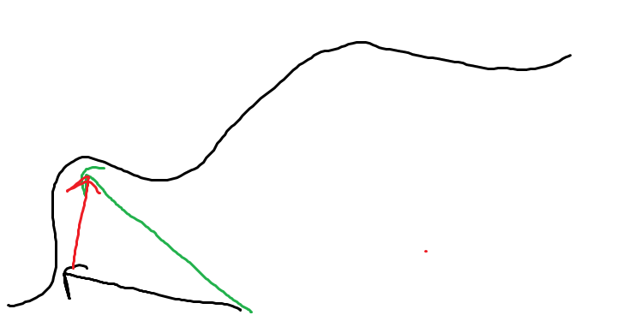

This is the geometrical representation, where the black vector is , the green vector is and the red vector is .

We can also take the second derivative which can represent for example the acceleration.

Example of 2nd derivative:

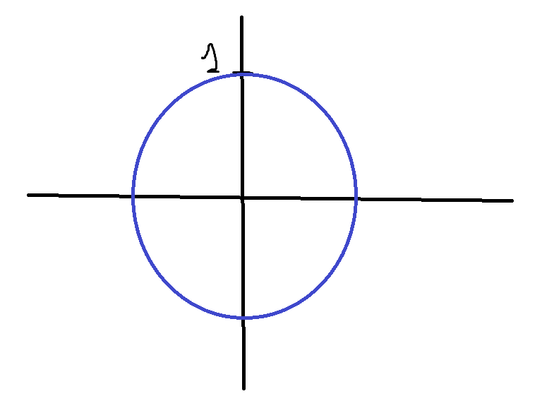**Consider the following example:**

This will produce a circular trajectory, because .

If it was for example that means that we are moving around the circle 7 times faster. However, the trajectory is still the same.

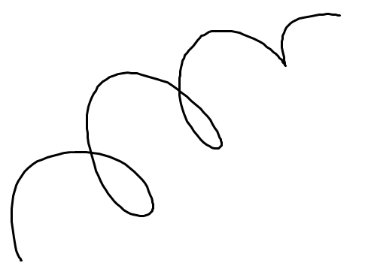5.2: Finding the length of a curve:

Finding the length of such a curve is complicated so we have 2 solutions:

1. Break the curve into small lines (Figure in red)
2. Reshape the curve into broken lines (Figure in green).

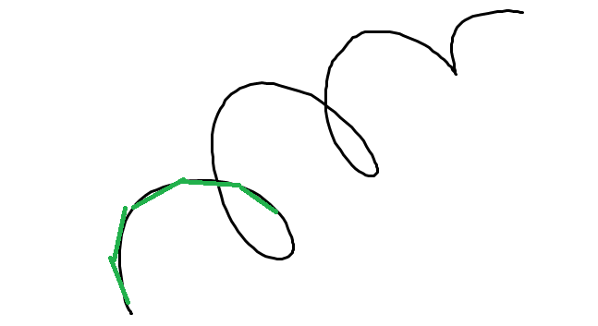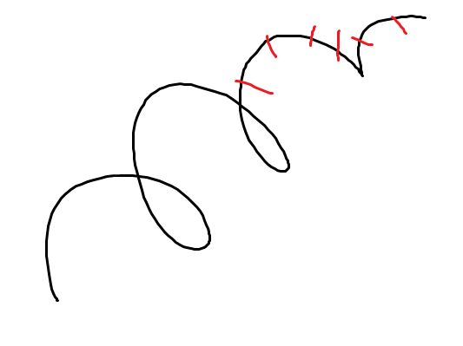

So, we can do it by integrating, the length of the curve is

**Projection for curves:**

Consider:

This is a circle that develops over time with . Find its length (length of 1 resolution):

Find

Now find

Now find the length:

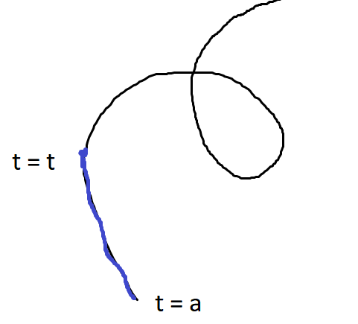5.3: Natural parametrization of the curve

So, we have, , and

Where is just the length of the segment (in blue).

That means, Natural parametrization:

This is a complicated integral. However, we have got the derivative , which is the function that we are integrating,

**Note**: and its magnitude is equal to .

# 5.4 Curvature of a curve

The curvature is related to how the unit vector changes along the curve defined

**Example:** Consider the following system, Find :

Find :

is a unit target vector so its magnitude and . That means that and thus:

So we can conclude that

Now we find :

# 5.5 Binormal and normal vectors:

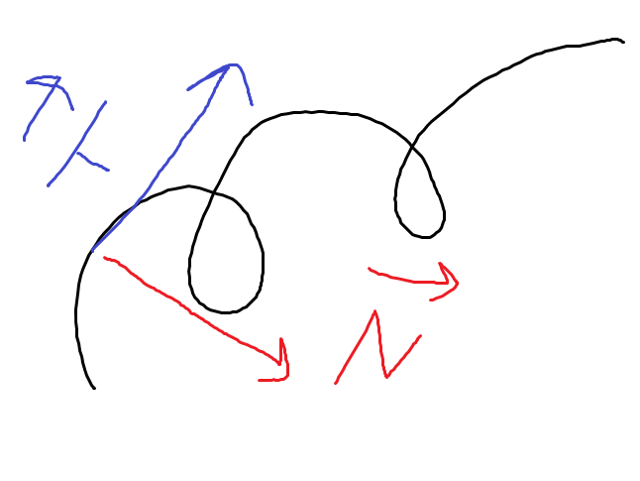We can conclude that . And all 3 of these vectors are unit vectors and their magnitude are 1.

**Example:** We have . Find velocity and acceleration:

where

6.0: Lecture 6 (January 24th, 2020)

# 6.1 Natural parametrization (continued)

Let , So its derivative

So, the **unit tangent vector**

Velocity

Acceleration

Which also is equal to

For the derivative of :

And for:

7.0: Lecture 7 (January 29th, 2020)

# 7.1 Partial derivatives:

Consider the function . Its derivative is

We use partial derivatives for functions that depend of multiple variables e.g. . Its partial derivative with respect to is .

*Example:* Find the

# 7.2 Differential of a function

So the differential of

# 7.3 Directional derivative

Example:

We have and with . Calculate the directional derivative.

Suppose we have a vector parallel to with magnitude of . Therefor, .

And then

Which mean that:

Note that is maximum when is parallel to the gradian. And it is minimum when has the opposite direction of the gradian.

***Example:* Find the direction derivative of , knowing that , and that is parallel to**

Find :

For this we need to find the gradian:

Now find , we know that it is parallel to :

But should be a normal vector so we have to divide by the magnitude:

Now we can calculate

*Example: .* Find curve and div :

* Curve

DENSOTY PROBLEM:

Lim = mass / length

9.0 Lecture 9 (14th February)

# 9.1 Lines integrals with respect to arc length

Example: from (0,-1) to (9,2)